**Introduction to the Oracle sample database -- PRODUCT**

We provide you with an Oracle sample database named OT which is based on a global fictitious company that sells computer hardware including storage, motherboard, RAM, video card, and CPU.

The company maintains the product information such as name, description standard cost, list price, and product line. It also tracks the inventory information for all products including warehouses where products are available. Because the company operates globally, it has warehouses in various locations around the world.

The company records all customer information including name, address, and website. Each customer has at least one contact person with detailed information including name, email, and phone. The company also places a credit limit on each customer to limit the amount that customer can owe.

Whenever a customer issues a purchase order, a sales order is created in the database with the pending status. When the company ships the order, the order status becomes shipped. In case the customer cancels an order, the order status becomes canceled. Each order will have a date of ordering and possibly salesman id (person who will process this order). Next, each order will have one more items (products) associated, together with the quantity and unit price.

In addition to the sales information, the employee data is recorded with some basic information such as name, email, phone, job title, manager, and hire date. Each employee (except President) will have an immediate Supervisor (or manager id), and also certain type of employee (Salesman) will process the orders placed by customers.

**Oracle sample database diagram -- PRODUCT ERD**

The following illustrates the sample database diagram or ERD for our PRODUCT set:

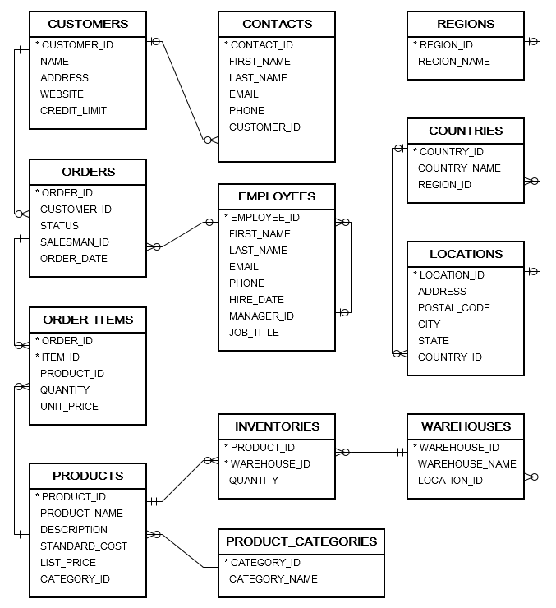

**Oracle sample database -- List of Tables in PRODUCT set**

The following illustrates the List of Tables and number of records in each sample table:

| **Table Names** | **Description** | **Records** |
| --- | --- | --- |
| CONTACTS | store contact person info of customers | 319 records |
| COUNTRIES | store country information | 25 records |
| CUSTOMERS | store customer master | 319 records |
| EMPLOYEES | store employee master | 107 records |
| INVENTORIES | store inventory information of products | 1112 records |
| LOCATIONS | store locations of warehouses | 23 records |
| ORDERS | store order header information | 105 records |
| ORDER_ITEMS | store order line items | 665 records |
| PRODUCT_CATEGORIES | store product categories | 5 records |
| PRODUCTS | store product information | 288 records |
| REGIONS | store regions where the company operates | 4 records |
| WAREHOUSES | store warehouse information | 9 records |